ProducED
Chronicles of the Living Castle
Game Host Manual
ProducED · version 1.0 · August 2026
For the on-site staff running the quest during a shift

Оглавление

1. Introduction
Chronicles of the Living Castle (CLC) is a fully immersive escape room: about 9 physical devices (the main board, 4 puzzle towers, 4 external ESP32 devices, sound, light) tied together by a server on a Raspberry Pi and a web control panel.
The Game Host is the staff member who:
- starts and ends the game session from the control panel;
- guides the group through the story and, if needed, gives voice hints;
- watches the players on camera;
- handles most unexpected situations alone — because a technician needs 1-2 days to reach the site, and a booking can be cancelled in that time.
Важно: This manual is written so you can solve 90% of problems yourself in 1-2 minutes: the Skip/Open Door button on the panel, a restart, or cutting the power for 20 seconds. Section 13 explains when to fix it yourself and when to call the technician right away.
The manual goes from simple to advanced: turning the quest on → working the control panel → the full walkthrough stage by stage (so you understand what players see and can help them) → common problems and their fixes.

2. Who's who in the story
A quick character reference — useful so your hints and explanations to players sound natural, in the language of the story, rather than “press the button on the panel.”
Character | Role in the story | Where you'll meet them
Signus | The dragon guardian of the Castle; explains the map and gives the first hints | Intro, Central Hall
Kai | The young student who must be rescued in the finale | Runs through the whole story; finale — the prison/basketball
Professor Amelia | Catches the players at night, sends them to collect the tower flags. Greets the players in the Attic once the rotary switches are set | Attic
The Wolf / the star story | A family story about the wolf and the night sky | Standalone Wolf-in-the-forest device
The gramophone on the platform | Hints for the train game | Standalone Train device
The creature in the safe | Hides, but will open the stash if given the pearl | Standalone Golden Safe device
Sylvester | A melancholic poet | Standalone Suitcases device
Elspeth | The witch who brews the broom potion | Potion room (Cat)
Brock | The troll in the mine, searching for metal for the train | Troll Mine
Boris | The master blacksmith who forges the broom and helmet for Kai | Workshop
The Library Ghost | Communicates by knocking, leads players to the Secret Library | Train, Wolf in the forest, Library (Ghost game)
The Banker | Hints at the safe combination | Bank (Mirror/Safe)
Cerberus | The sleeping dog on the rotating platform | Dog Tower
Headmistress Eleonora | Head of the school; lights the Cup of Unity | Upper Tower (Cup room)

3. Turning the quest on and off

Turning on
- Slide the special wand into the dedicated hole in the Castle wall — this is the physical power switch.
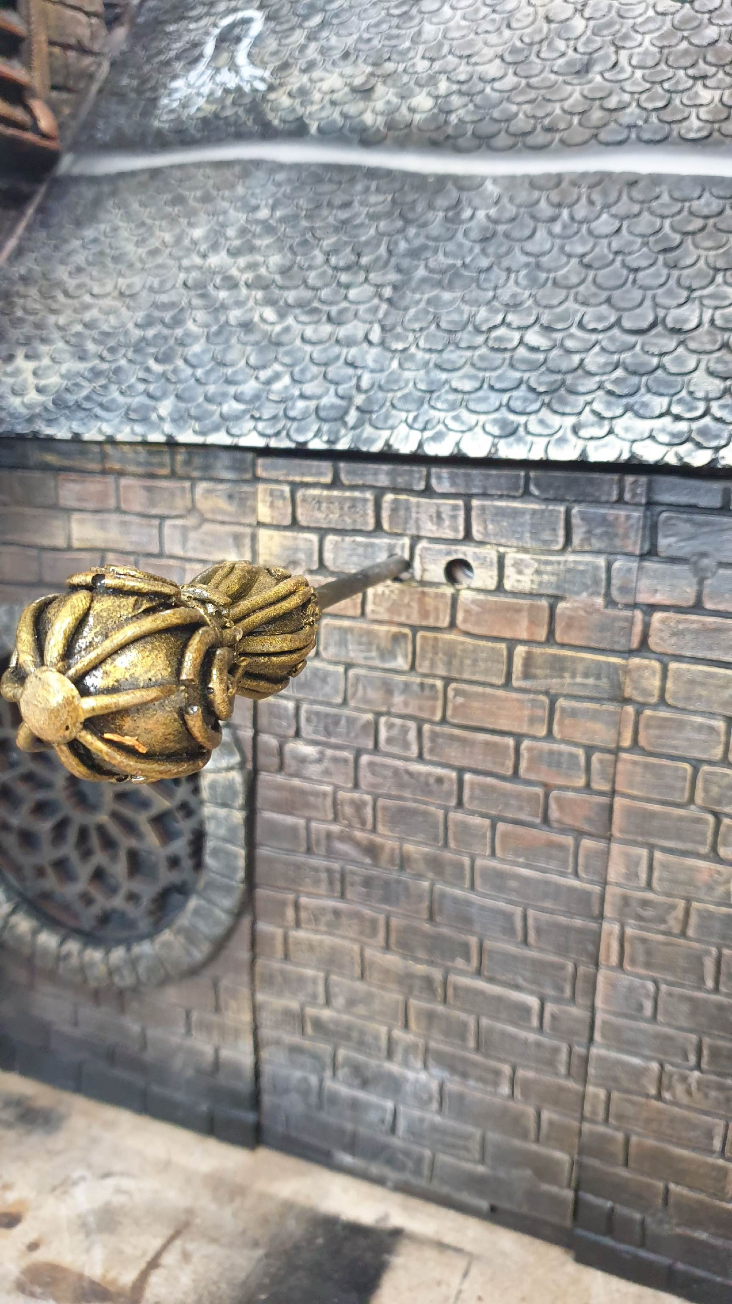
- If that switch was already turned on before, simply restoring power at the site (flipping the outlet/breaker) is enough.

Turning off
- In the panel's Settings, press the red power button.
- Wait 20 seconds — the server shuts down cleanly and records a “shut down properly” flag (without it, the panel shows a warning next time it starts).
- Use the wand to flip the switch through the neighbouring hole in the wall — or simply cut power to the room at the site.
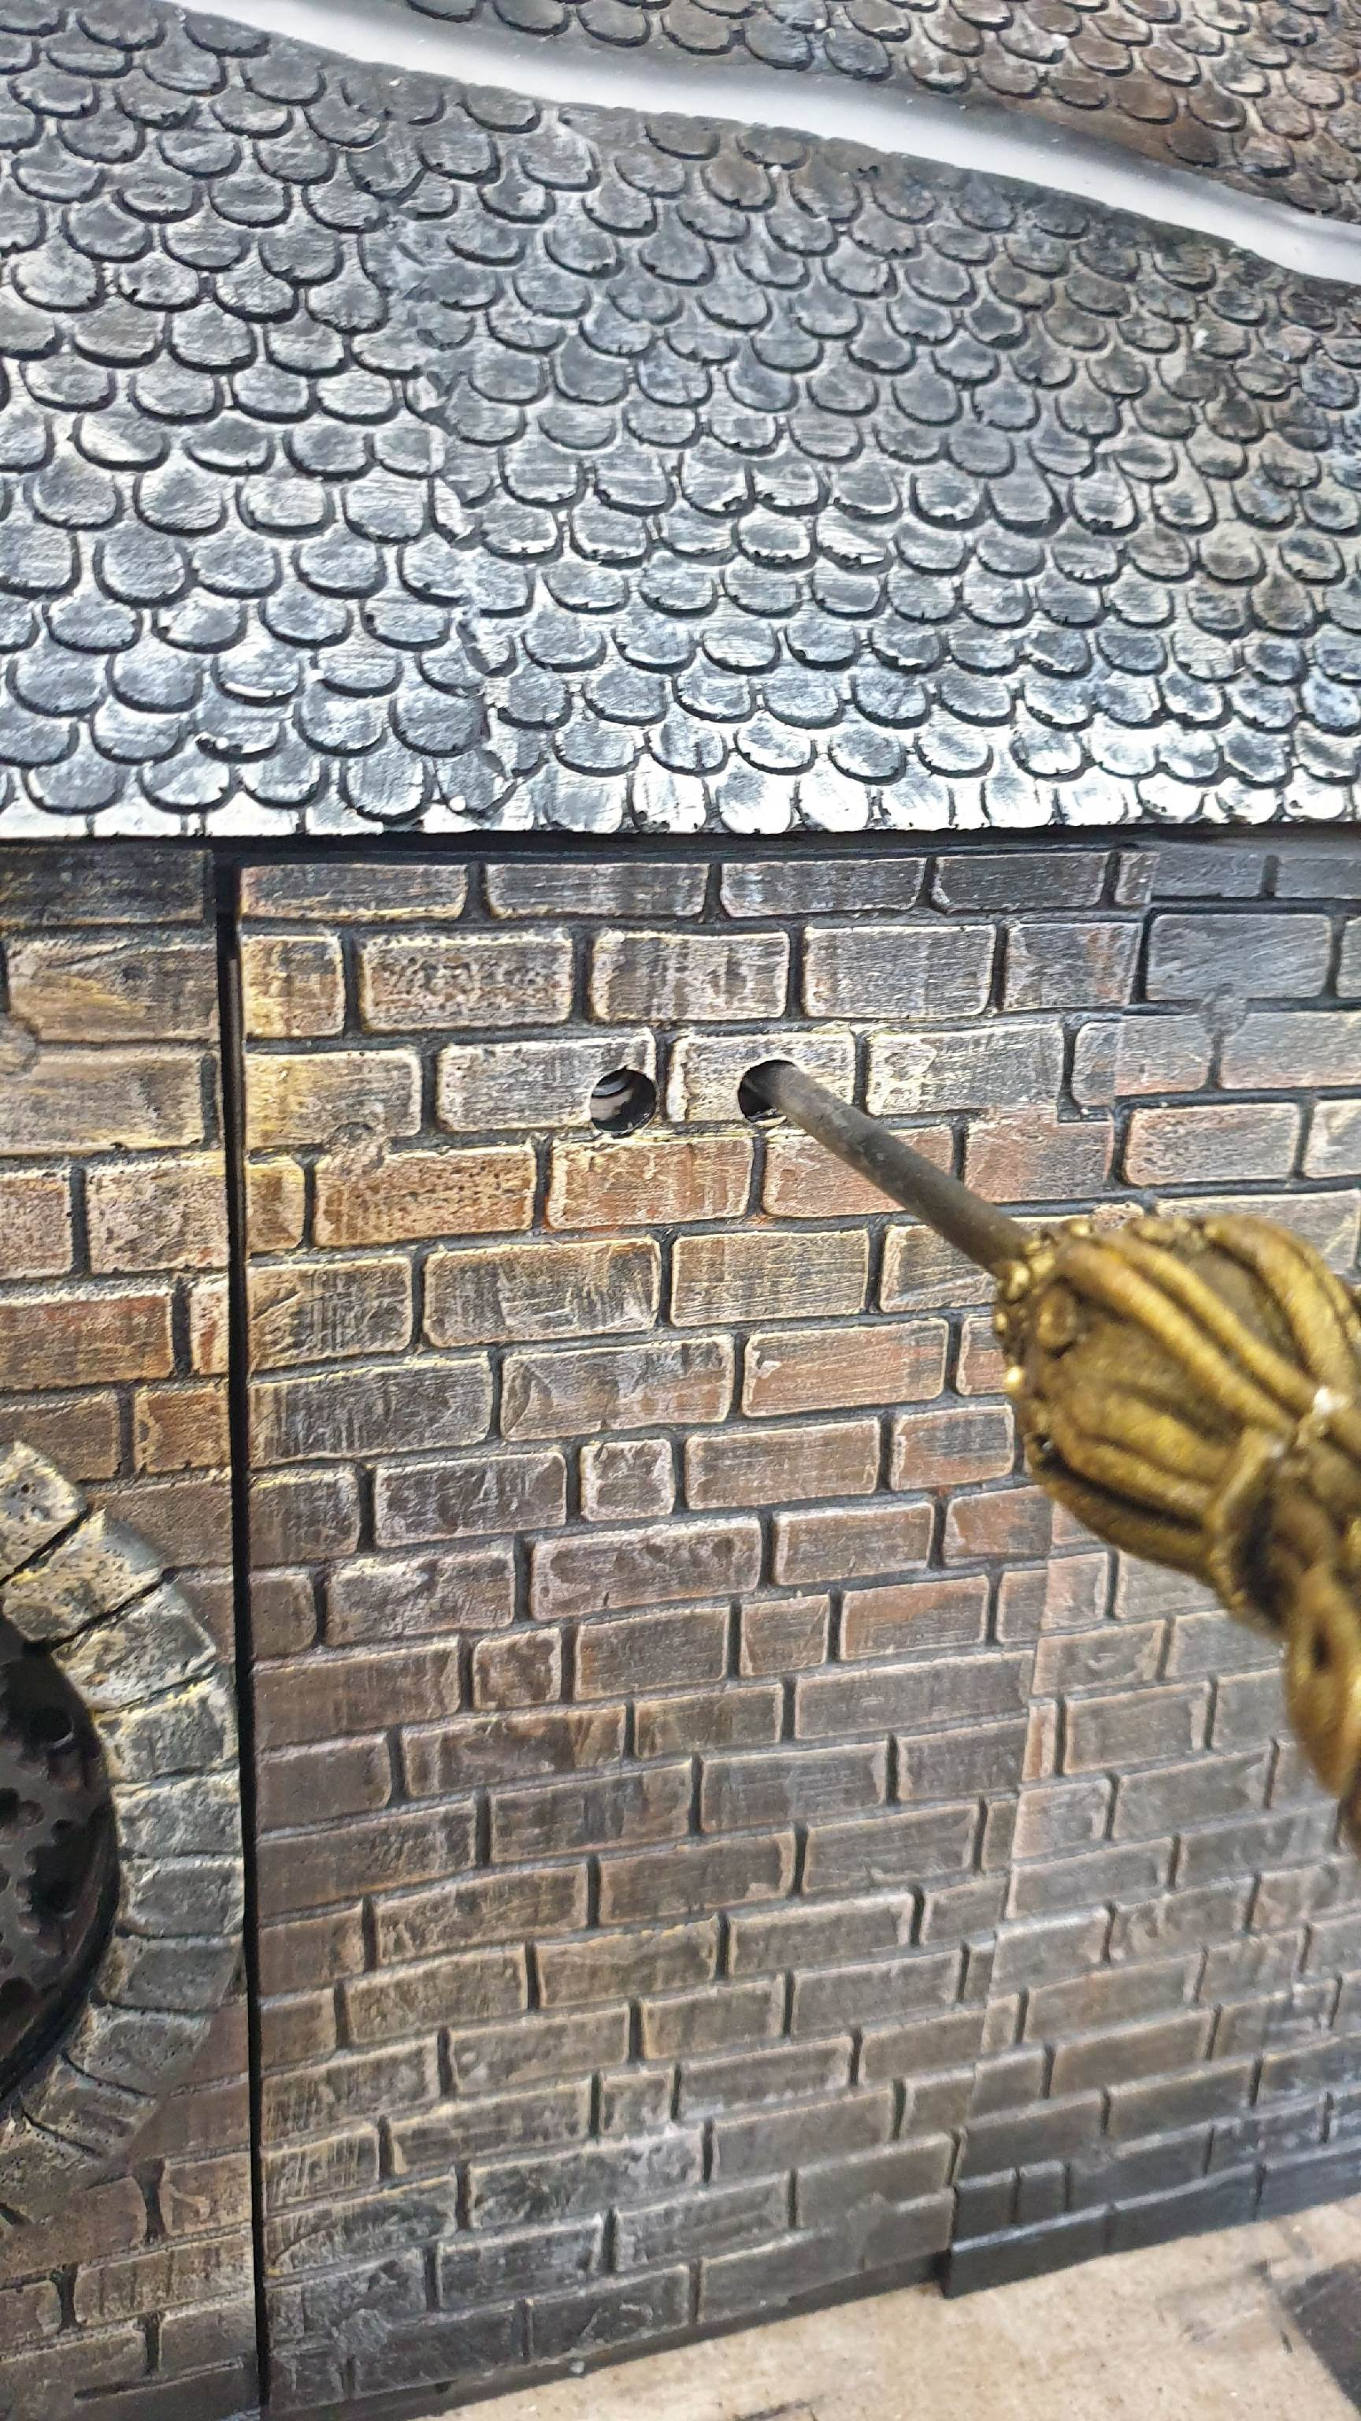
Важно: If the quest was shut down improperly (power just pulled, without pressing the red button), the panel will show a warning the next time it starts. This is not a fault — you can dismiss the warning and keep working.

4. Connecting to the control panel
You can open the panel from any device with a browser — phone, tablet, laptop — that is on the same Wi-Fi network as the Castle.

Option 1 — the Castle's own network (main)
- Connect to the Castle's Wi-Fi network (usually named Castle).
- Address: http://castle.local or http://192.168.4.1:3000
- Panel password: questquest (unless the technician changed it during setup).

Option 2 — through the site's own router
If the quest server is connected to the site's internet/Wi-Fi (the client's own router), the panel is also reachable on that network — usually at an address like 192.168.x.x:3000. Confirm the exact address for your site with technical support during setup — it is unique to each installation.
Tip: Save the panel page to your phone/tablet home screen (or bookmark it in the browser) — it will speed up access during a shift.

5. The control panel screen: overview
The main screen is a map of the Castle made of cards: each card is one room or tower, and inside it are the specific puzzles for that area.
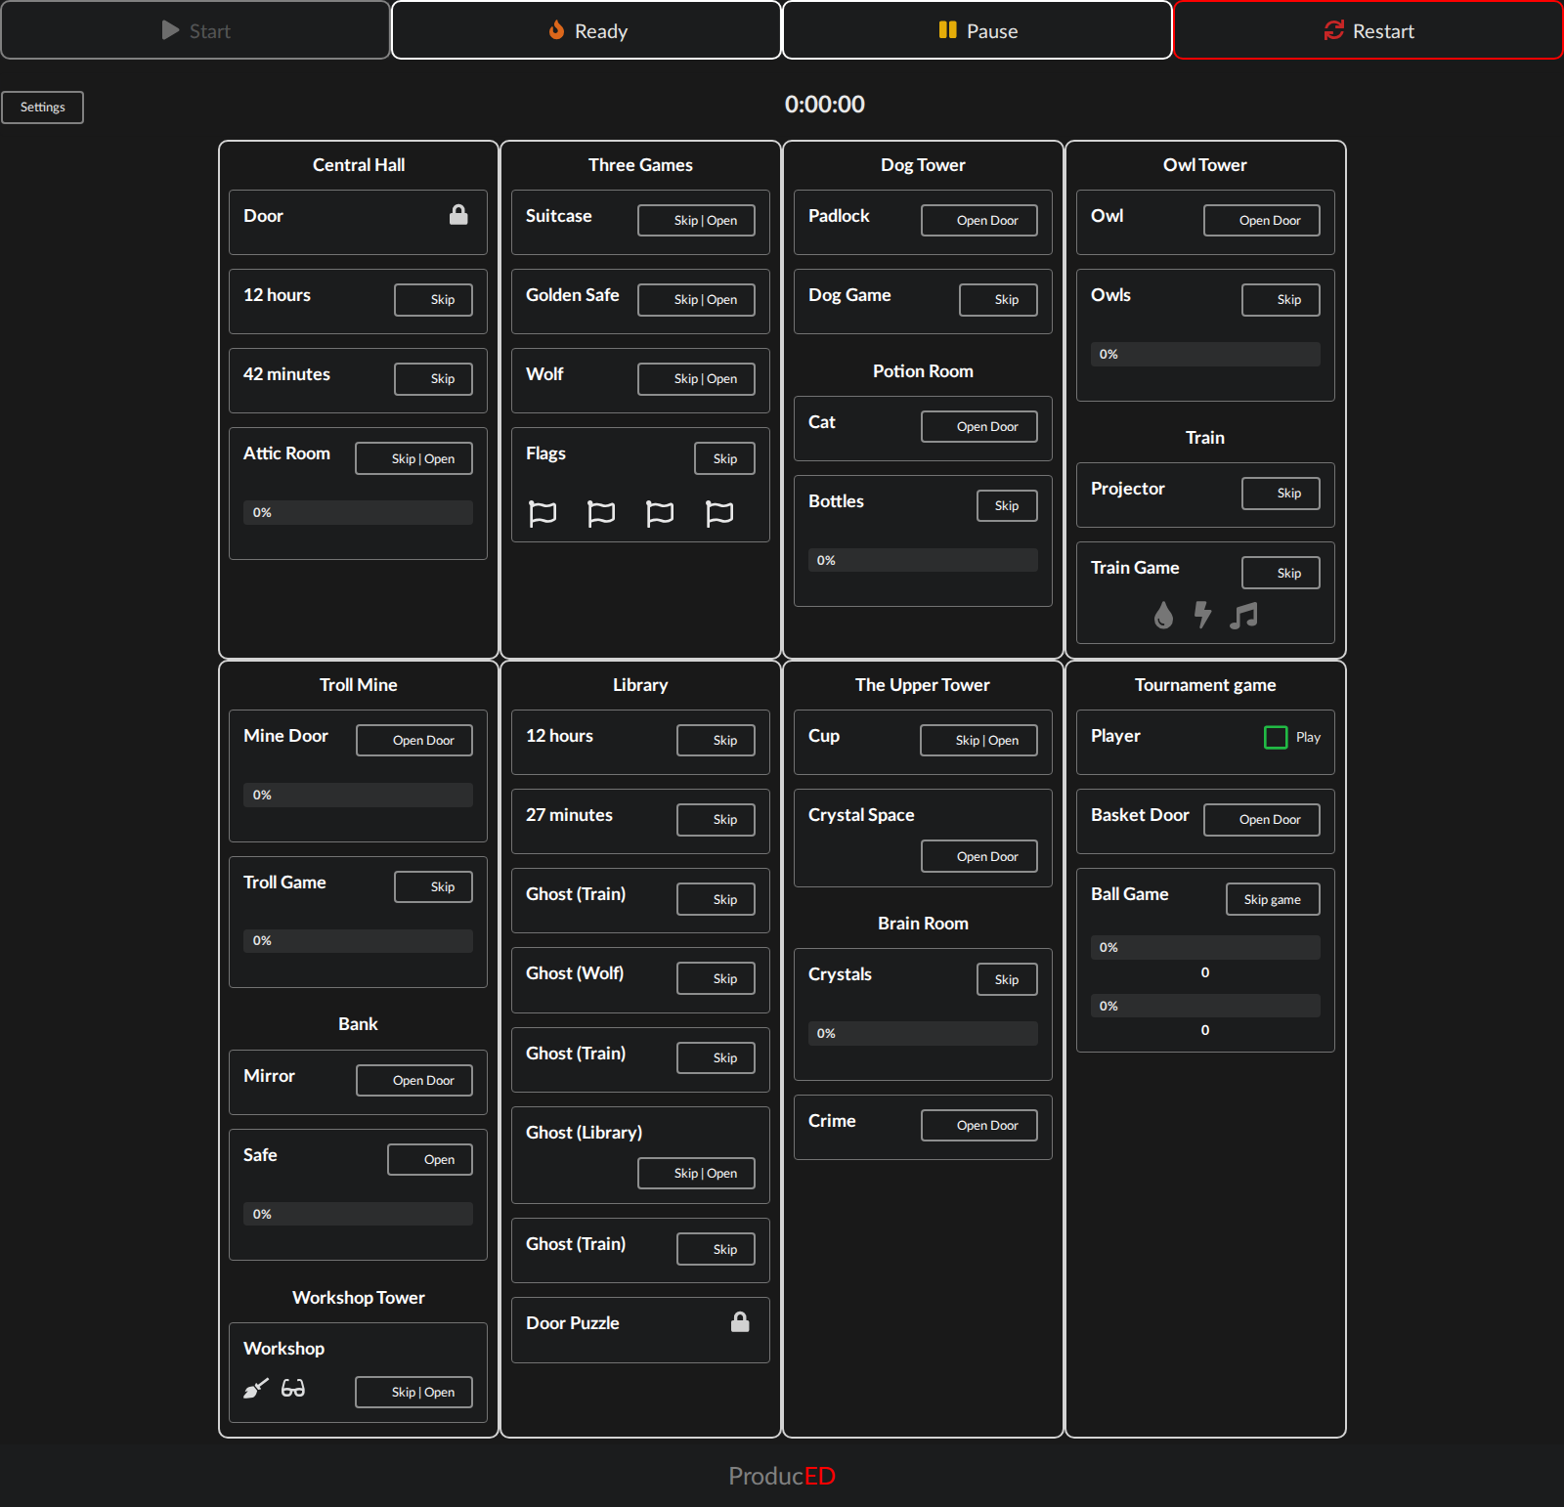
Operator's main control panel screen

Top bar
Button | Purpose
Start | Starts the timer and the game logic (becomes active once the sensor check has passed and every item is back in its place)
Ready | Checks that every sensor is ready before a new game — the “green light” to start. Full list of errors — Section 7
Pause | Pauses the game (only available while a game is running)
Restart | A full reset: opens every lock in the quest plus the external devices

Room cards
Each card holds one or more puzzles. Most have a “Skip | Open” button (two actions in one, see Section 10); some show a progress bar (0-100%) showing how far the puzzle has physically progressed right now.

6. Control panel settings
Opened with the Settings button in the top-left corner. Every toggle is labelled directly in the interface — here is the full breakdown:
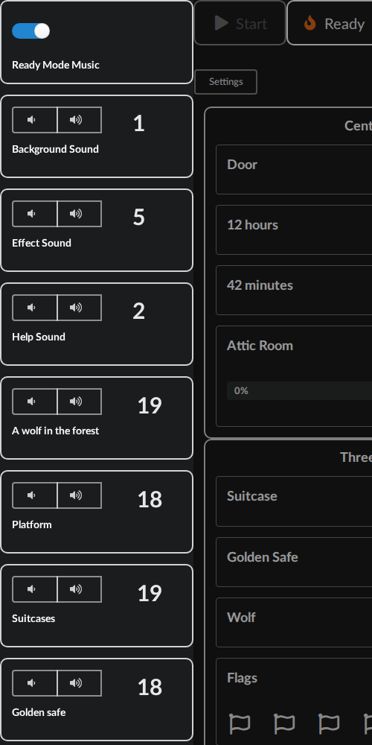 | 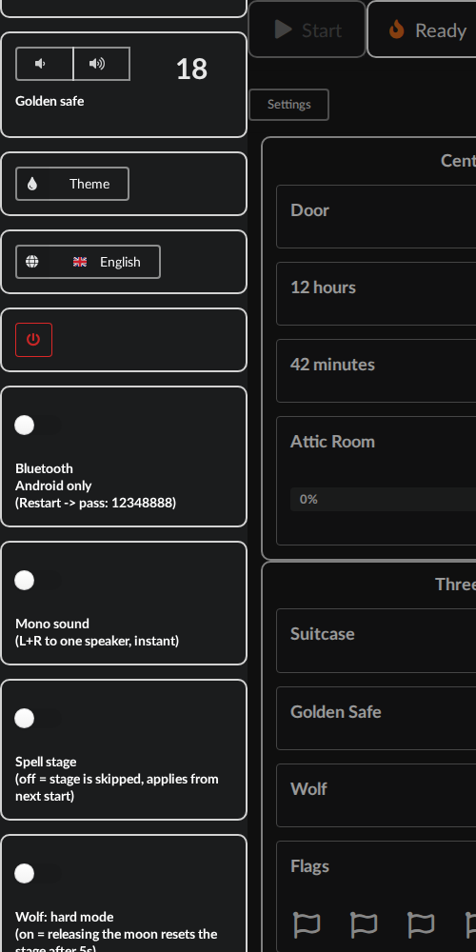 | 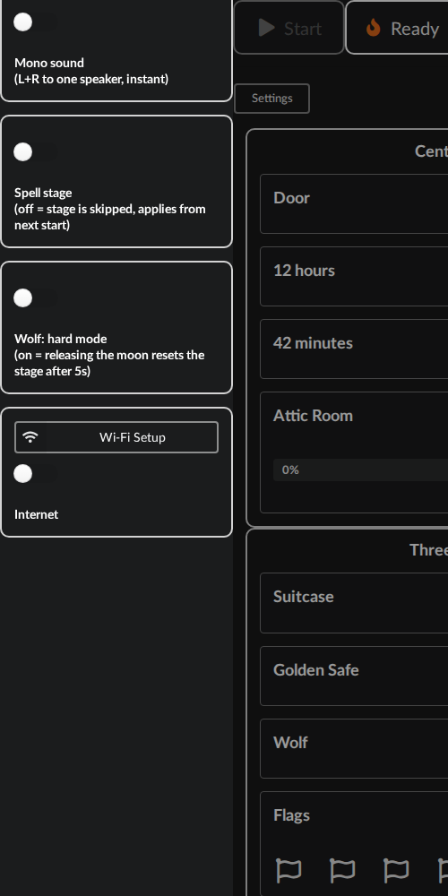
The full settings panel (scrolled down across 3 screenshots)

Setting | What it does
Ready Mode Music | Turns the background music on or off while the panel is in Ready (waiting-to-start) mode
Background / Effect / Help Sound | Volume of the background track, sound effects, and hints (narrator's voice) inside the Castle itself
A wolf in the forest / Platform / Suitcases / Golden safe | Volume of each external device's own speaker (Wolf / Train / Suitcases / Safe)
Theme | Black/white colour theme of the panel screen itself — cosmetic only, does not affect the game
Language | Language of the story narration and hints inside the Castle (ru/en/ar/fr/uk/pl)
Power button (red) | Cleanly shuts down the server — see Section 3
Bluetooth | Android only, only while in Restart mode. Pairing code: 12348888. Turns the Castle's audio into a Bluetooth speaker.
Mono sound | Merges the left and right speaker channels into one — turn on if a client describes the sound as “only coming from one side”; switches instantly. Also turn it on if you've wired mono speakers instead of stereo.
Spell stage | Off = the spell stage (wand swipes by the fireplace) is skipped entirely. The change applies from the next Start/Ready — it does not affect a game already running
Wolf: hard mode | On = releasing the moon too early rolls the Wolf stage back after 5 seconds. Off = unlimited time. Applies immediately.
Wi-Fi Setup | Configures the Pi's own outgoing Wi-Fi (for internet/OTA updates) — normally not needed during a shift
Internet | Allow/block the Castle's guest network from reaching the internet through the Pi (off by default). Turn on if you want a phone or tablet connected to the Castle network to have internet access.

7. The Ready button: what the errors mean
Ready is not a check of “is the device turned on” — it is a live check of the position of every physical sensor in the Castle. If anything was left in its “triggered” position after the previous game or the build, Ready will fail and show a list.
Message on the panel | What to physically check
A wolf in the forest | The Wolf device is not responding — offline/frozen/no Wi-Fi
Platform | The Train device is not responding
Suitcases | The Suitcases device is not responding
Golden safe | The Golden Safe device is not responding
Check Flags | One of the flags (on the Workshop/Dog/Owls/Basket towers) has not been put back in its starting place
Check SUN Switch | The rotary switch on the Workshop tower has not been reset
Check BOAT Switch | The rotary switch on the Owls tower has not been reset
Check ROSE Switch | The rotary switch on the Dog tower has not been reset
Check WAVE Switch | The rotary switch on the Basket tower has not been reset
Check TREE Switch | The central rotary switch (Central Hall) has not been reset
Check Start Door | The start door is not physically closed
Check Crystals | A crystal in the memory room is lifted / not in its place
Check Kay | Kai's figure has been taken out of the cell and not put back
Check Library | The Library puzzle door has not been put back in place
Check Bank Safe | The bank safe's door is open
Check Crime | The prison door is not closed

Важно: The fix is always the same: physically put the listed item back in its starting position and press Ready again. If the error is about a device (Wolf/Train/Suitcases/Safe) — see Section 12, “An ESP32 controller isn't responding.”

8. The full quest walkthrough
A detailed description of what players must do at each stage — so you can hint in the language of the story if a group is stuck, and know which panel button to use if a specific piece breaks down.

8.1 Central Hall (start)
- Players find the key hidden under the dragon Signus's wing and use it to open the Castle's central gate. A reed switch triggers — Kai appears on his servo mount.
- They touch the wand to the clock showing “12” — UV light makes numbers appear on the wall.
- They find the number “42” on the wall and touch it with the wand — the lights in the Attic turn on.
Note: The “12 hours” reed switch is used TWICE over the game — the second time in the Library (Section 8.8), but with a different number (27).

8.2 Attic — rotary switches
Each of the 4 towers, plus the Central Hall, has a rotary switch. Each one must be set to the right position: yellow = sun (Workshop), blue = drop (Basket), red = rose (Dog), brown = boat (Owls), green = tree (Central Hall). Once all five are set, the Attic door opens and players meet Emily.

8.3 Three parallel games (any order)
The Attic unlocks three external devices at once. Players can solve them in any order — each gives one flag.

a) The Wolf in the forest
Set the moon so its magnet closes the reed switch and it lights up. While the moon is lit, the right cloud is lit too; rotate it so its beam hits the tree (the tree has 3 reed-switch levels, each lighting its own LED). Hitting the top level lights the left cloud — the tree “relays” the light. Turn the left cloud so its beam hits the eye of the wolf's silhouette — the eye LED lights up from its reed switch. At that moment, turn the wolf toward the silhouette in time: within 5 seconds in hard mode (see the Wolf hard mode setting) or at any time in normal mode, as long as players keep holding the clouds in place. Once the wolf's reed switch closes on cue, the lock opens with the flag inside.

b) The Golden Safe
Press the lever — the ball bounces and lands in the maze. Turning the maze with the two handles, move the ball into the right hole (a crossing sensor fires) — the lock opens with the flag inside.

c) The Suitcases
Press and HOLD the 4 black buttons on the vertical suitcase in the right order, without releasing them — then, by sliding the handles on the horizontal suitcase in and out, build the pattern against the diorama background. Each correct button lights a light inside the horizontal suitcase; a mistake lights it red, and the sequence must be started over. Once the pattern is set and the crossing sensor fires, the lock opens with the flag inside.

8.3.1
Place all the flags found so far on the four tower roofs.
Each flag has its own spot on its tower's roof, marked by the animal shown on the flag. Once all four are placed, four parallel games activate on the map (Section 8.4).

8.4 The map: 4 parallel lines (any order)
On the map above the train there are LEDs: yellow = available now, white = not yet available, off = completed, shimmering = an active spot to touch with the wand. Next to each is a reed switch: touching it with the wand (which has a magnet on its tip) starts a visual timer (a spinning LED disc), and within that time you must touch the matching symbol on the Castle itself or on the train. The pairs to touch: train on the map = the train's lantern; owl on the map = the owl on the Owls tower; key on the map = the lock on the Dog tower (Cerberus); fish on the map = the cat on the Castle wall.

Train ↔ the train's lantern
Starts the train game: the train has 3 potentiometers. One sets the colour to purple, judged against the lantern's LED. Another removes the LED's flicker so it glows steadily. The third listens to the engine sound and makes it steady. On success, the tunnel lights up and a hint combination appears: the order in which to touch the symbols on the Troll Mine's door with the wand (the gramophone at the train station gives the hint).
Key link: Completing the train game is exactly what unlocks access to the Troll Mine — without it, you won't get the hint for touching the symbols on the mine door.

Owl ↔ the owl on the Owls tower
Opens the door to the Owls tower. Inside, players rotate the Gnome so his lantern lights one of 4 tiles, revealing a crest. The symbols for that crest's rotary switches are shown in the attics of each of the four towers (the lights there turn on the moment the Gnome moves off its default position while rotating). Once both symbols are set for every crest, the stage is complete.

Key ↔ the lock on the Dog tower (Cerberus)
Opens the lock on the Dog tower. Inside is a knight's armour holding a frightened magical creature that gives hints to players if they touch the armour with the wand. In the middle of the room, Cerberus sleeps on a rotating platform: the platform must be turned SLOWLY so as not to wake the dog. On a full rotation, the cage latches into the lock. If turned too fast, the dog wakes up and the lock won't latch until the tower door is closed (which puts Cerberus back to sleep). A successful slow full rotation — the latch clicks shut — lights the crystal on the wall.

Fish ↔ the cat on the Castle wall
Opens the potion room (the witch Elspeth, the cauldron). Players must place the bottles into the cauldron in the right order to brew the potion.
Важно: Full walkthrough and puzzles for the Troll Mine — Section 8.5.

8.5 Troll Mine
The lock opens once you touch the symbols on the Castle tower's door with the wand in the right order (each symbol has a reed switch behind it; the train game gives the hint, Section 8.4). Once the door is open, the troll Brock must be turned so his lantern “finds” the spot in the cave where the metal is hidden. The troll finds the wrong metal three times and only the fourth time the right one — after which the crystal starts glowing.

8.6 Bank
Unlocks once all five lines on the Map are complete (Sections 8.4-8.5): a candle lights up and must be BLOWN OUT by physically blowing into the window — a reed switch opens and the Bank door unlocks. The Banker gives hints. On the right wall is a safe with a dial: turning it, close the reed switches in the right order with a short hold on each, until you hear a click at every position. The safe then opens, revealing a gold bar inside.

8.7 Workshop
After the story plays, the door to the blacksmith Boris in the Workshop tower opens. Players must physically BLOW into the forge to stoke the fire; once the fire level is between 2 and 3 (visible from its brightness), they assemble the combination for the helmet and the broom on the workbench (4 slots). To move an item to the workbench, first touch it in another room, then touch the matching slot (reed switch) on the workbench — the addressable LED lights up in that item's colour. Once the right colour combination is set, the helmet or the broom lights up. If the fire goes out during the process, the workbench combination resets and must be started over.
Важно: Once both the helmet and the broom are assembled, Kai appears again in the Central Hall, and the ghost must be summoned once more (Section 8.8) — but with different numbers this time: 12 and 27.

8.8 Library and the Ghost
Touch the wand to the clock at “12”, then the number “27” on the wall (unlike the first time in 8.1, which used 12 and 42). A knock is then heard on the Platform (train) device — knock back physically and a vibration sensor will pick it up. The knocking then moves along a chain: Platform → Wolf in the forest → Platform → the Castle towers (knock on the ghost painted on the wall) — the Library door opens, and the knocking returns to the train once more. Knocking there reveals a constellation hint on the side of the platform — needed to open the Library's second, inner door. Opening it (the magnet leaves the reed switch) makes Kai vanish from the Central Hall, as if something grabbed him. Morning arrives.

8.9 Upper Tower — the Cup
The upper door of the central tower opens: inside are a fireplace, a cup, and Headmistress Eleonora. Touch the wand to the fire first, then to the cup. If Spell stage is enabled in the settings, players must then swipe the wand across the arrows on the floor (left-right-left-right-left, 5 swipes total) to open the basement door. If Spell stage is disabled, the basement door opens right after the cup is activated.

8.10 Memory Room
In the basement, players must pick up all 4 crystals in their hands — 4 reed switches wired in parallel open, unlocking the door to the room with the brain. There, a logic puzzle about remembering colours awaits: place the 4 crystals back in the correct order. Once solved, the crystals “speak,” revealing where Kai is hidden, and a secret door — the prison — opens in the Central Hall.

8.11 Prison and Basketball
Players free Kai from his cage, and the door to the Basketball tower opens. Kai is placed back on his mount, starting a basketball lesson: first catch the ball flying around the Castle (on the addressable strip), then shoot it into the hoop with the seesaw button. Once the ball is scored, the main game starts: score 3 goals against the opponent. The opponent plays too, scoring on its own unless its balls are intercepted by pressing the touch button at any of the four spots next to the addressable strip. After the win, fireworks fire on the Castle and on every external device — the quest is complete.

9. Hints for players
There is no separate “Hint” button on the panel — hints are fully automatic. If a player touches the crystal on any character inside the quest, that character speaks the next hint, escalating each time: first a light nudge, then something more direct, then a plain instruction.
- Hint volume is controlled by the same slider as “Help Sound” in the panel settings (Section 6).
- The more automatic hints played during a game, the lower the final rating (stars) at the end.
- If a group is clearly stuck and the automatic hints aren't helping, feel free to step in and hint by voice, using the stage descriptions in Section 8.

10. Skip and Open Door — the difference
Most stages have two actions in one button on the panel: “Skip | Open.”
Button | What it does | When to use it
Skip | Simulates finishing the stage in full: counts it as won, plays the matching story, moves the plot forward — as if players had solved the puzzle themselves | A device/sensor is physically broken, but progress must continue during the game
Open Door | In Start mode: simulates finishing the stage in full and opens the lock. In Restart mode: only opens the lock. | You need to physically open a door for a check, cleaning, or a rebuild — for example during Restart or shift setup

Важно: In the Restart/Ready state, some buttons don't do anything at all — only the physical Open Door actions for doors are available there. The skip buttons for the mini-games (Dog Game, Troll Game, Train Game, etc.) do nothing in that state — that's normal, they only work DURING a game.

11. Manual release wire: opening a lock by hand
The repair kit that ships with the quest includes a manual release wire — a 2 mm diameter piece of wire. Every lock has a small release lever built in: pressing on it with the wire through the hole in the housing releases the lock mechanically, with no electronics involved. This works on EVERY door fitted with a lock — use it if the electronic release (Open Door on the panel) doesn't work for some reason and the group needs to move on right away.
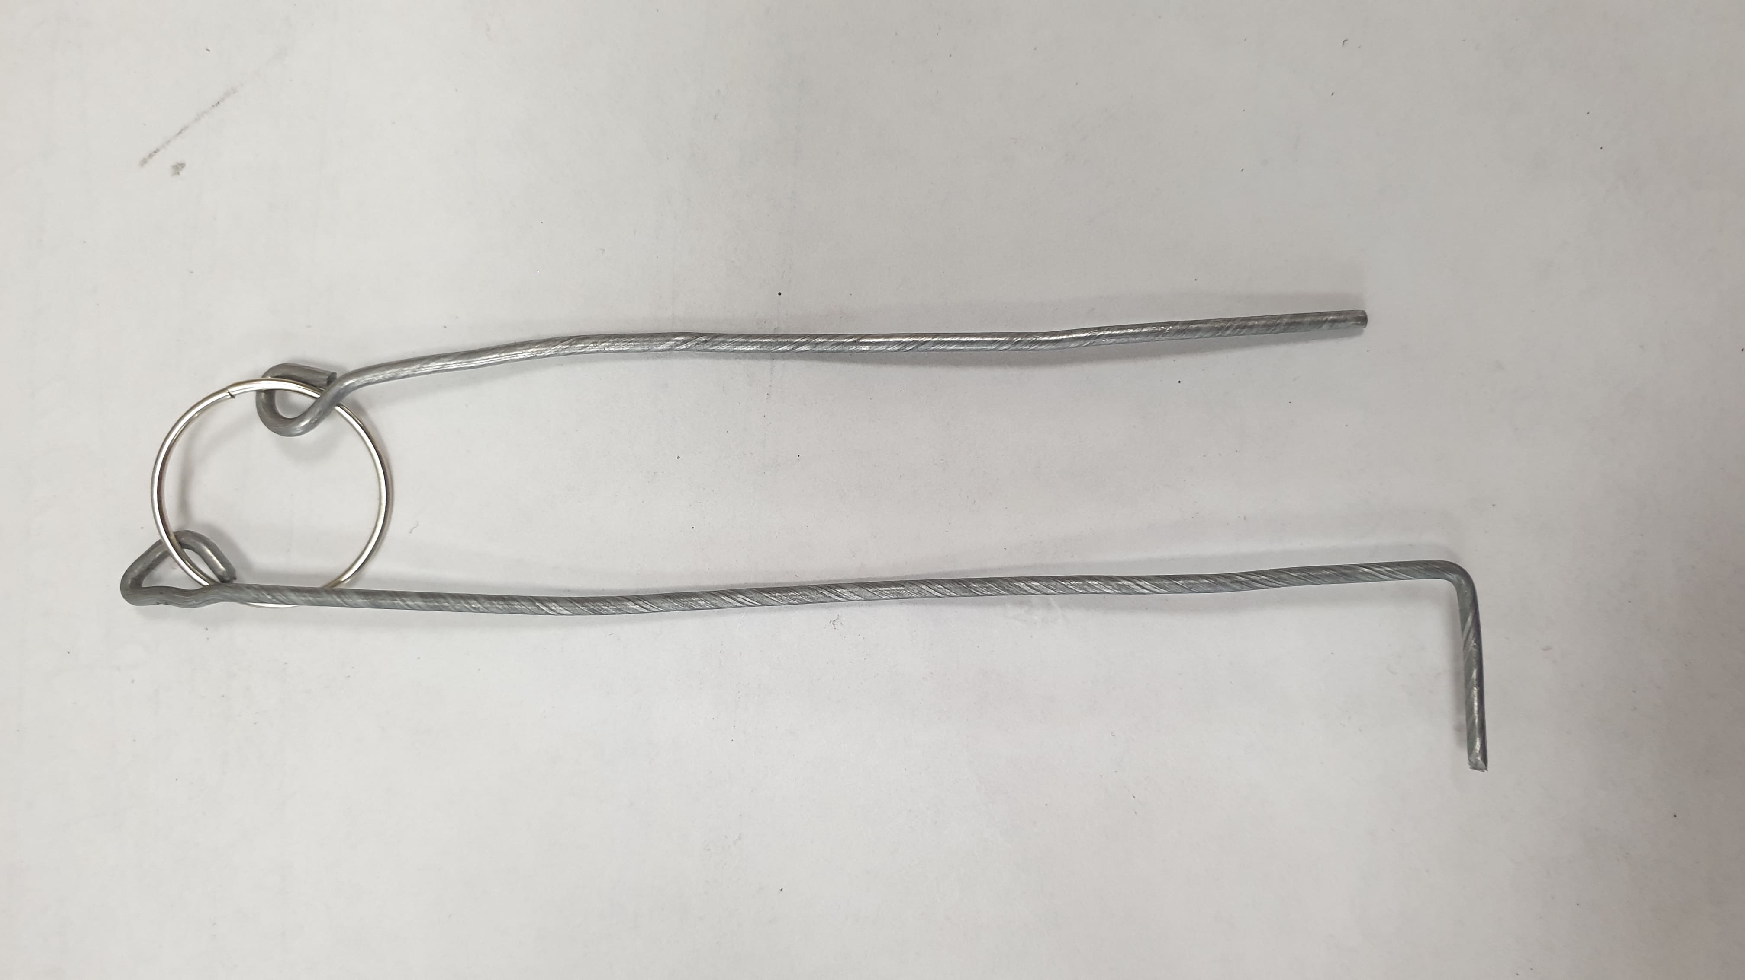

12. Common problems and fixes
Symptom | What to do
A door doesn't open on cue (the sensor didn't fire) | Press Skip for that stage on the panel — if the group did everything correctly but the sensor didn't respond
A door won't open even with Open Door / Skip | Open it with the manual release wire (Section 11) and continue the game. Report the case to the technician after the shift
One external device (Wolf/Train/Suitcases/Safe) isn't responding, Ready shows an error | Cut power to that device for 15-20 seconds (find its own power switch) and turn it back on — this usually fixes a network hiccup or a freeze
The panel won't open, but the Castle Wi-Fi network is visible | Do NOT just reboot — it won't help. Fully cut power to the server (the Pi) for 20-30 seconds and turn it back on
No startup sound (on.wav) within 5 seconds of powering up | Wait a little longer; if it stays silent, cut power to the quest for 15-20 seconds and turn it back on
Ready shows an error even though everything looks set up correctly | Check against the table in Section 7 — it's almost always a rotary switch, a flag, or a door that hasn't been reset. Physically check the listed item
Players say the sound only comes from one speaker | Turn on Mono sound in the panel settings (Section 6) — it merges both channels into one. Then let the technician know.
Not every door opened after a Restart | Go through each card on the panel and press Open Door wherever a door didn't actually open
Something is smoking, sparking, or making an unusual crackling sound | Cut power to the whole quest at the site IMMEDIATELY and call the technician — do not try to fix it yourself

13. When to fix it yourself, and when to call the technician

Handle it yourself (see Section 12)
- One sensor/door isn't working — you have Skip and the manual release wire.
- A Ready error — it's almost always a physical item out of place.
- One device offline — cutting power for 15-20 seconds usually fixes it.
- The panel won't load, but the network is up — fully cut power to the server.

Call the technician right away
- Signs of damage: smoke, a burning smell, sparks, an unusual crackling sound.
- The panel doesn't open AT ALL (and the Castle network isn't visible either) even after fully cutting power for 30+ seconds.
- The problem keeps coming back every shift, and cutting power only fixes it temporarily.
- Mechanical damage — a cracked housing, a torn-off wire, an object stuck in a mechanism that won't come out.
Важно: This is a guideline, not a strict rulebook — confirm the final criteria with management as you gain more operating experience.

14. Ending a game and getting ready for the next group
- Press Restart on the panel — all 9 Castle doors and the towers' internal locks open.
- Walk through every room and physically reset the props: rotary switches to neutral, flags taken off the roofs and stored under the Attic holder, bottles removed from the cauldron, crystals back on their pedestals, Kai's figure back in its holder, the cup back in its starting position.
- Close every door that needs to be closed to start (the start door, the Library, the safe, the prison).
- Press Ready and check against the error list (Section 7) — if the list is empty, the panel turns green and the quest is ready for the next group.

15. Control panel glossary
Term | Meaning
Ready | Checks that the sensors are ready before a new game starts
Restart | A full reset — opens every door and every internal lock
Skip | Simulates finishing a stage without a physical action from the players
Open Door | Only opens the lock mechanically, without changing the game state
Socklist / devices | The internal list of sensors that haven't fired yet — it's what builds the Ready error messages
Diag (diagnostics) | A technical mode for checking sensors and outputs — used only by the technician, not during a game shift

